MODULE: STANDARD OPERATING PROCEDURE (SOP)

OVERVIEW

Learning Objectives

At the conclusion of this module, you will be able to:
- [Interpretation] Define the acronym SOP and describe the purpose and utility of an SOP
- [Interpretation] Identify elements that appear on an SOP
- [Interpretation] Identify the importance of SOPs to research
- [Application] Write an SOP for a non-scientific procedure
- [Evaluation] Evaluate an SOP for a scientific procedure

Materials for this Module
- Handout 1: SOP for Weighing a Sample
- Handout 2: SOP Template

Introduction
Why is a Standard Operating Procedure (SOP) important? SOPs are the backbone of conducting research. SOPs by definition are “detailed, written instructions to achieve uniformity of the performance of a specific function”. An SOP is a means of capturing the proper and safe way to perform a task so that you or someone else can perform the same task in the same way. In essence, if you perform an experiment in the lab, you should be able to hand those instructions to a lab mate, and they should be able to complete the same experiment. To take this a step further, you should be able to give an SOP to someone in a different lab at your university, a lab across the country, or a lab in a different country, and everyone should be able to successfully complete the experiment. Creating a high-quality SOP is hard work and requires iteration.

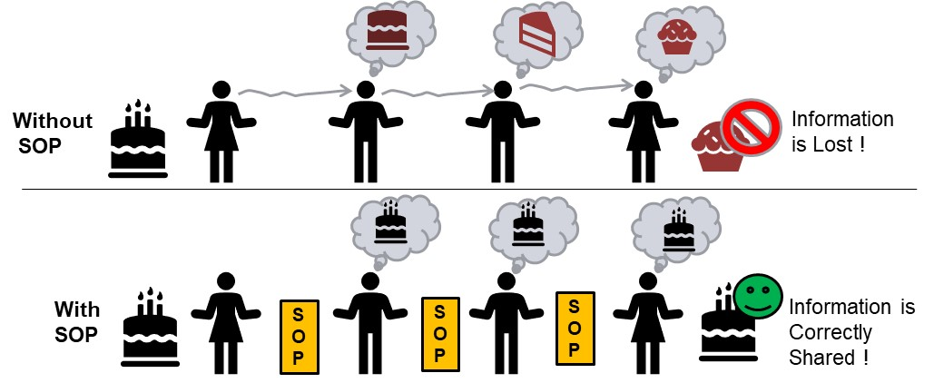

Managing SOPs:
SOPs must be maintained and readily available in order to be useful. Once an SOP is completed it must be available to anyone in the lab who needs to use it and kept up to date with any changes in materials, equipment, procedures or supplies. The most up-to-date versions of SOPs should be made available in a common location such as printed in a folder, shared on a computer, or accessed through a website. Everyone must know where to go to access the current version. Note that SOPs are valuable to anyone who wants to reproduce a process. Thus, the SOP may contain restricted information that is a competitive advantage to your laboratory. You are obligated to protect the information in the SOP. SOPs are often part of training a new person to complete a task. A training record may be attached to an SOP. The document will have information such as name of trainer, name of trainee, date of training and date of re-training if necessary. The trainer will be the person who generated the SOP or another employee who is the person responsible for that task.

Elements of an SOP:
Many companies and laboratories have their own style and content for an SOP (they have their own SOP for writing an SOP!). To achieve the core purpose of communicating information about how to reproduce a process, all must have some common elements. Some elements are required, while others are optional. The following figure shows an SOP describing the use of a scale (more complete version in Handout 2). Note the details and structure needed in an SOP for a simple task. Each step that should be taken is listed in order. This SOP was written to anticipate some choices such as user preference of metric or imperial units. It also explains how to add the chemical in small increments so that the scale is used properly. This specific knowledge was gained from the scale documentation and many users attempting to follow the SOP. Someone probably asked, “What is that flashing arrow on the side?”; the SOP was then updated so no one who used the scale would be uncertain about this important feature.

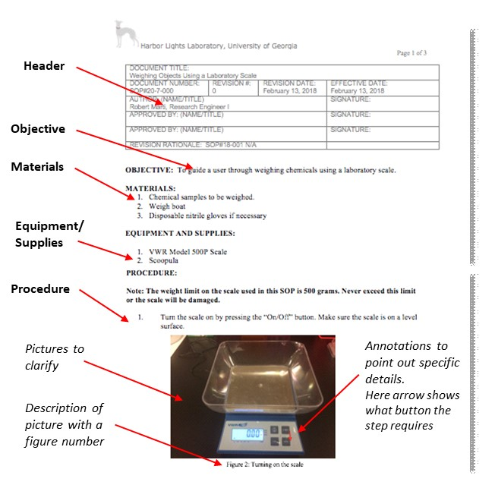

Assignment(s) for this Module

SOP Activity:

Review Handout 2, which is a sample SOP describing the use of a scale. Note the details and structure needed in an SOP for a simple task. As you read, consider:

Does it seem too detailed for such a simple activity?

ANSWER: The SOP needs to be written so that any two users can produce the exact same result. Any place where one user may deviate from the procedure must be specified, described, and justified. You should never have to ask “Did I do that step correctly?”

What happens when you get a new scale?

ANSWER: Again, creating a high-quality SOP is hard work and requires iteration. Documentation of each step, including images, must be considered carefully. Several users should attempt to follow the revised SOP before it is finalized.

Your turn! Follow the template provided in Handout 2, SOP Template, and create an SOP on how to make a peanut butter and jelly (PB&J) sandwich. Assume that you will provide this SOP to an individual with no concept of a PB&J sandwich; they will build the sandwich from your instructions alone. A quality SOP will be thorough enough to guide them through the process from start to finish. Refer to the scale example in Handout 1 when you have questions about the necessary amount of detail or formatting.

Deliverable 1: Document your PB&J sandwich SOP (Handout 2).

Five-Minute Reflection:
- Come up with one question to discuss with your mentor (maybe a concept you are unclear on, something you found interesting, etc.).
- What information did you feel was the most informative? Least?
- Why are SOPs so important to research and collaboration?
Deliverable 2: Document your responses to the Five-Minute Reflection.

Mentee Deliverables:

Deliverable 1: Peanut butter and jelly sandwich SOP (Handout 2).

Deliverable 2: Responses to the Five-Minute Reflection (Overview).

Discussion with Mentor:

Things that can go wrong during SOP development and later implementation

Review of peanut butter and jelly sandwich SOPs

Grasp of research papers

Research project fit in “big picture” (referring to other papers/publications)

Five-Minute Reflection

Summary
- Standard Operating Procedures (SOPs) are the backbone of conducting research.
- Your job is to ensure that your experimental results are accurate and reproducible; otherwise, you have wasted everyone’s time and valuable resources.
- Note that SOPs are valuable to anyone who wants to reproduce a process. Thus, the SOP may contain restricted information that is a competitive advantage to your laboratory. You are obligated to protect the information in the SOP; consult your research mentor before sharing.

Checklist

Prior to Meeting with Mentor:
- Review Handout 1: SOP for Weighing a Sample
- Use Handout 2: SOP Template to document making a peanut butter and jelly sandwich
- Read relevant research papers that you’ve found or that were suggested by your mentor
- Complete the Five-Minute Reflection

