**OBJECTIVE:** To guide a user through weighing chemicals using a laboratory scale.

**MATERIALS:**

1. Chemical samples to be weighed.
2. Weigh boat
3. Disposable gloves if necessary

**EQUIPMENT AND SUPPLIES:**

1. VWR Model 500P Scale
2. Scoopula

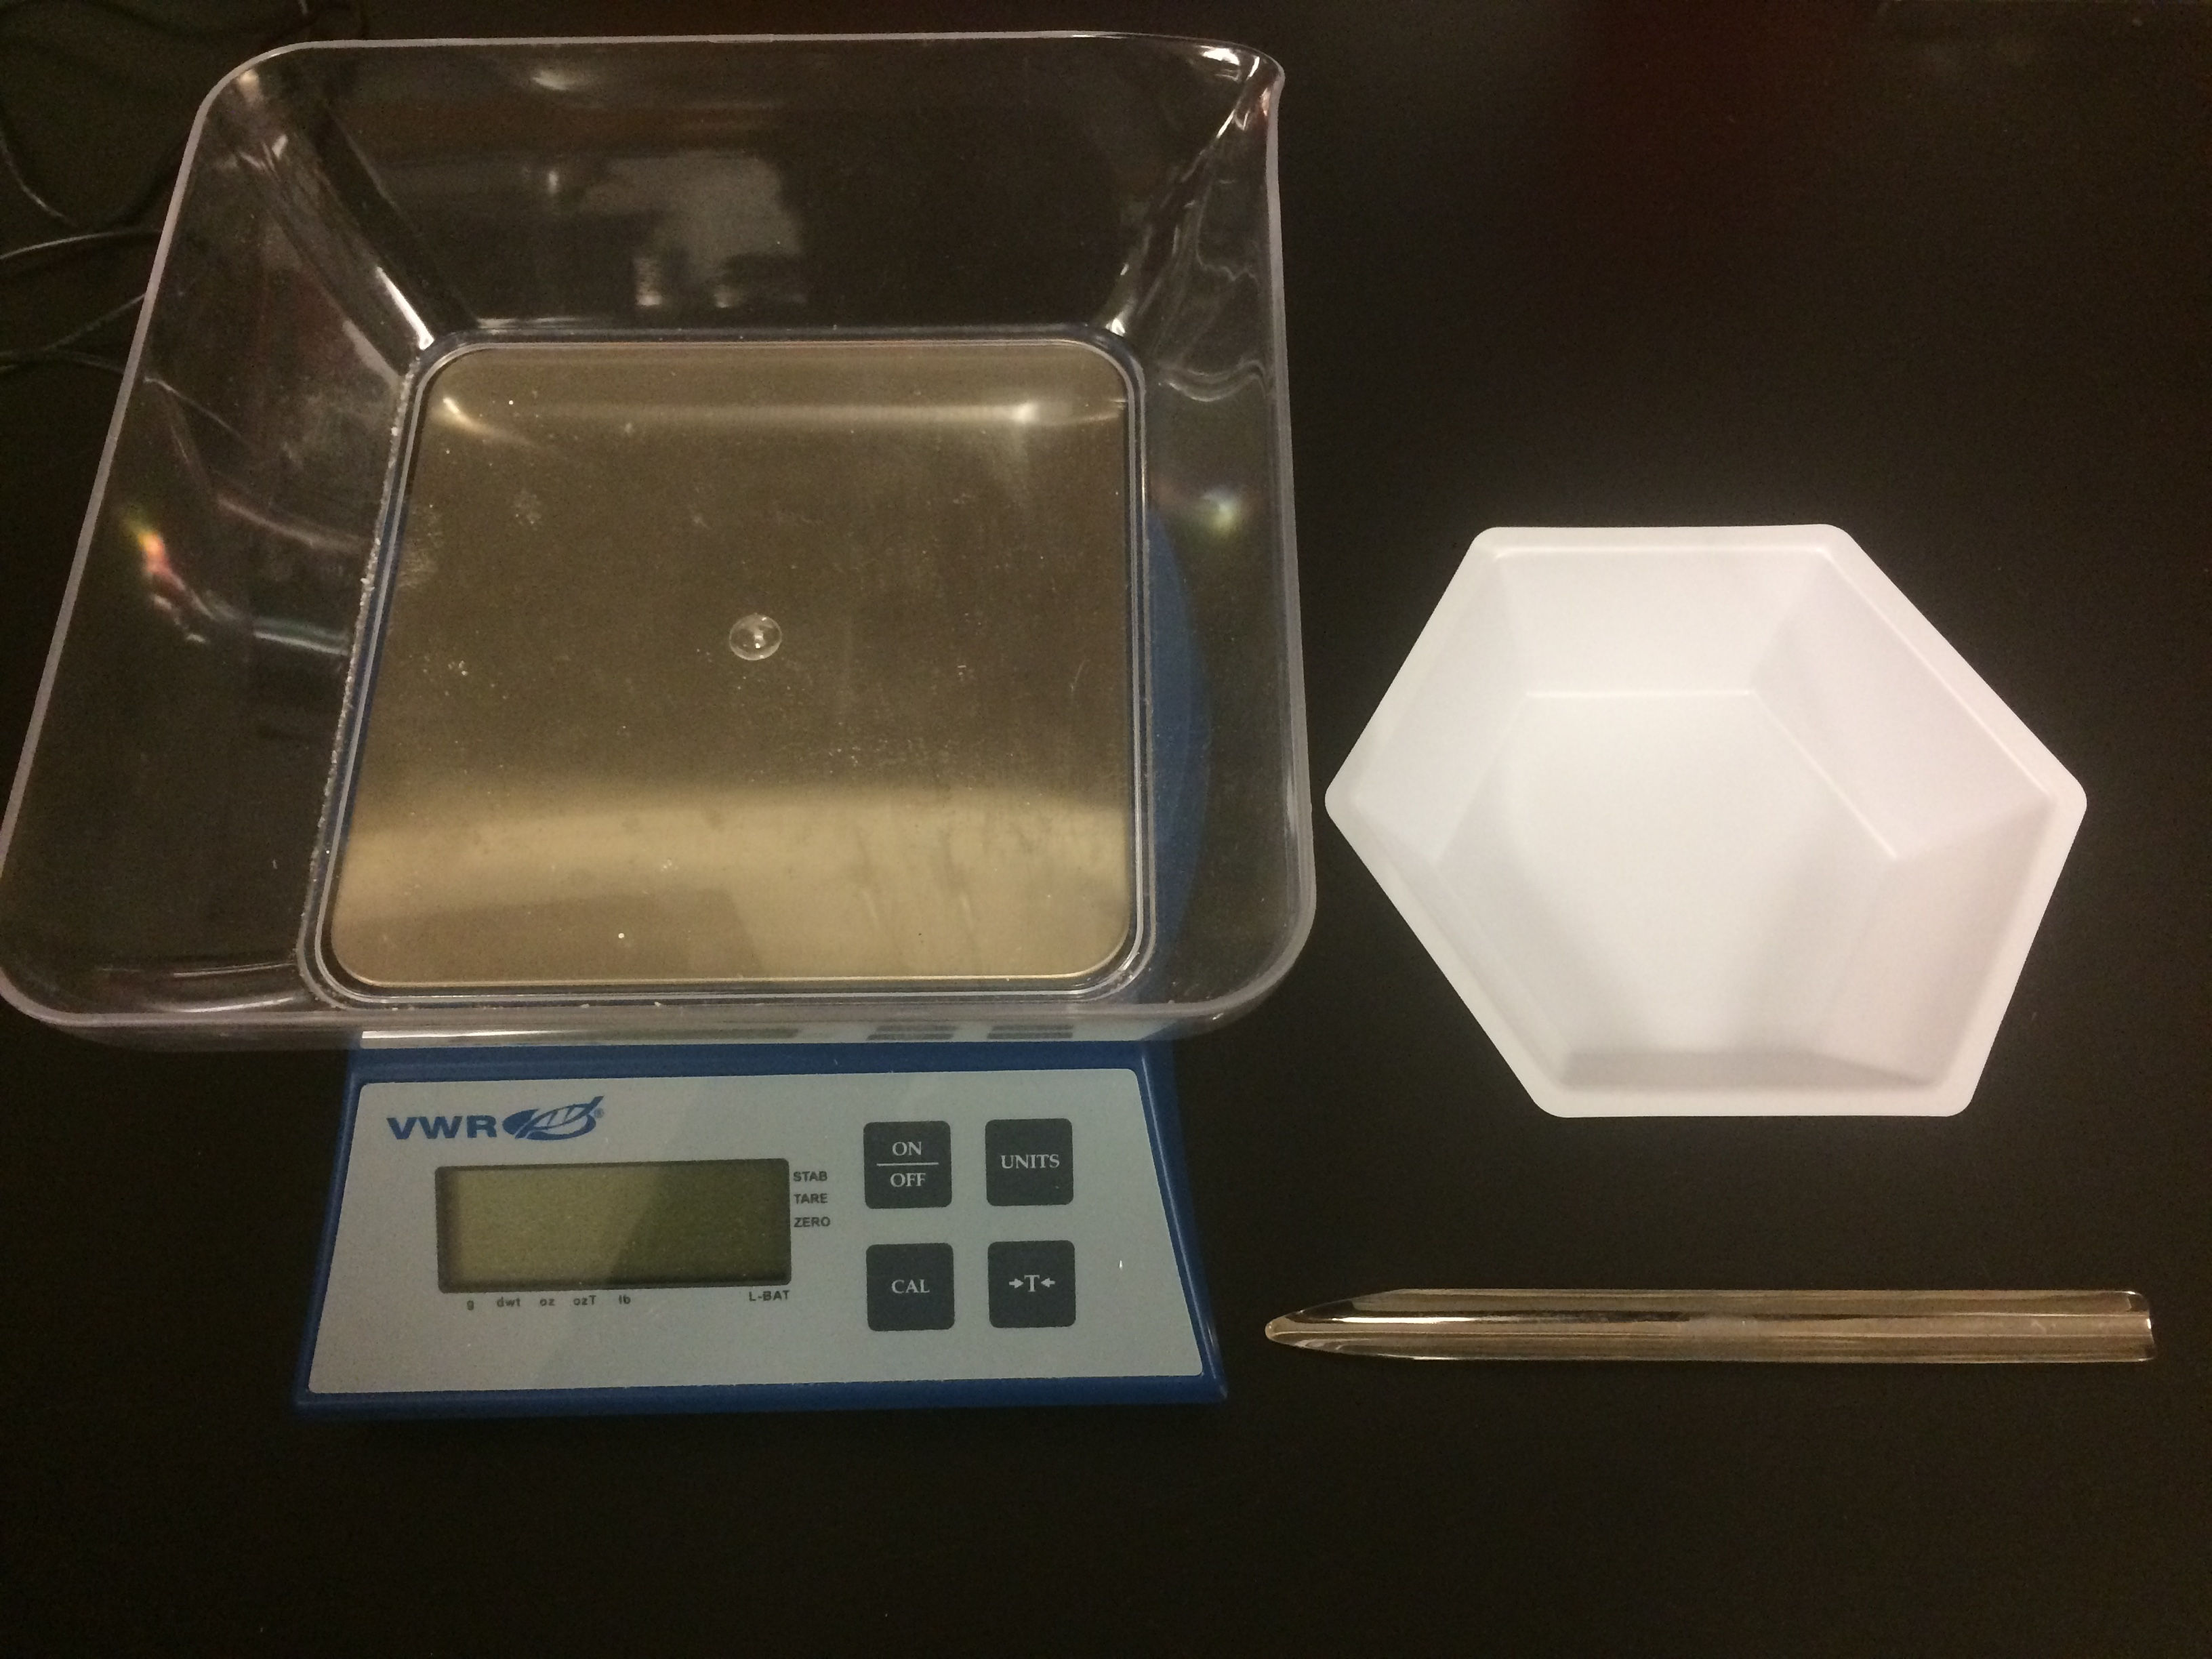

**1**

**2**

**3**

Figure 1: Equipment needed to perform SOP

**PROCEDURE:**

**Note: The weight limit on the scale used in this SOP is 500 grams. Never exceed this limit or the scale will be damaged.**

1. Turn the scale on by pressing the “On/Off” button. Make sure the scale is on a level surface.

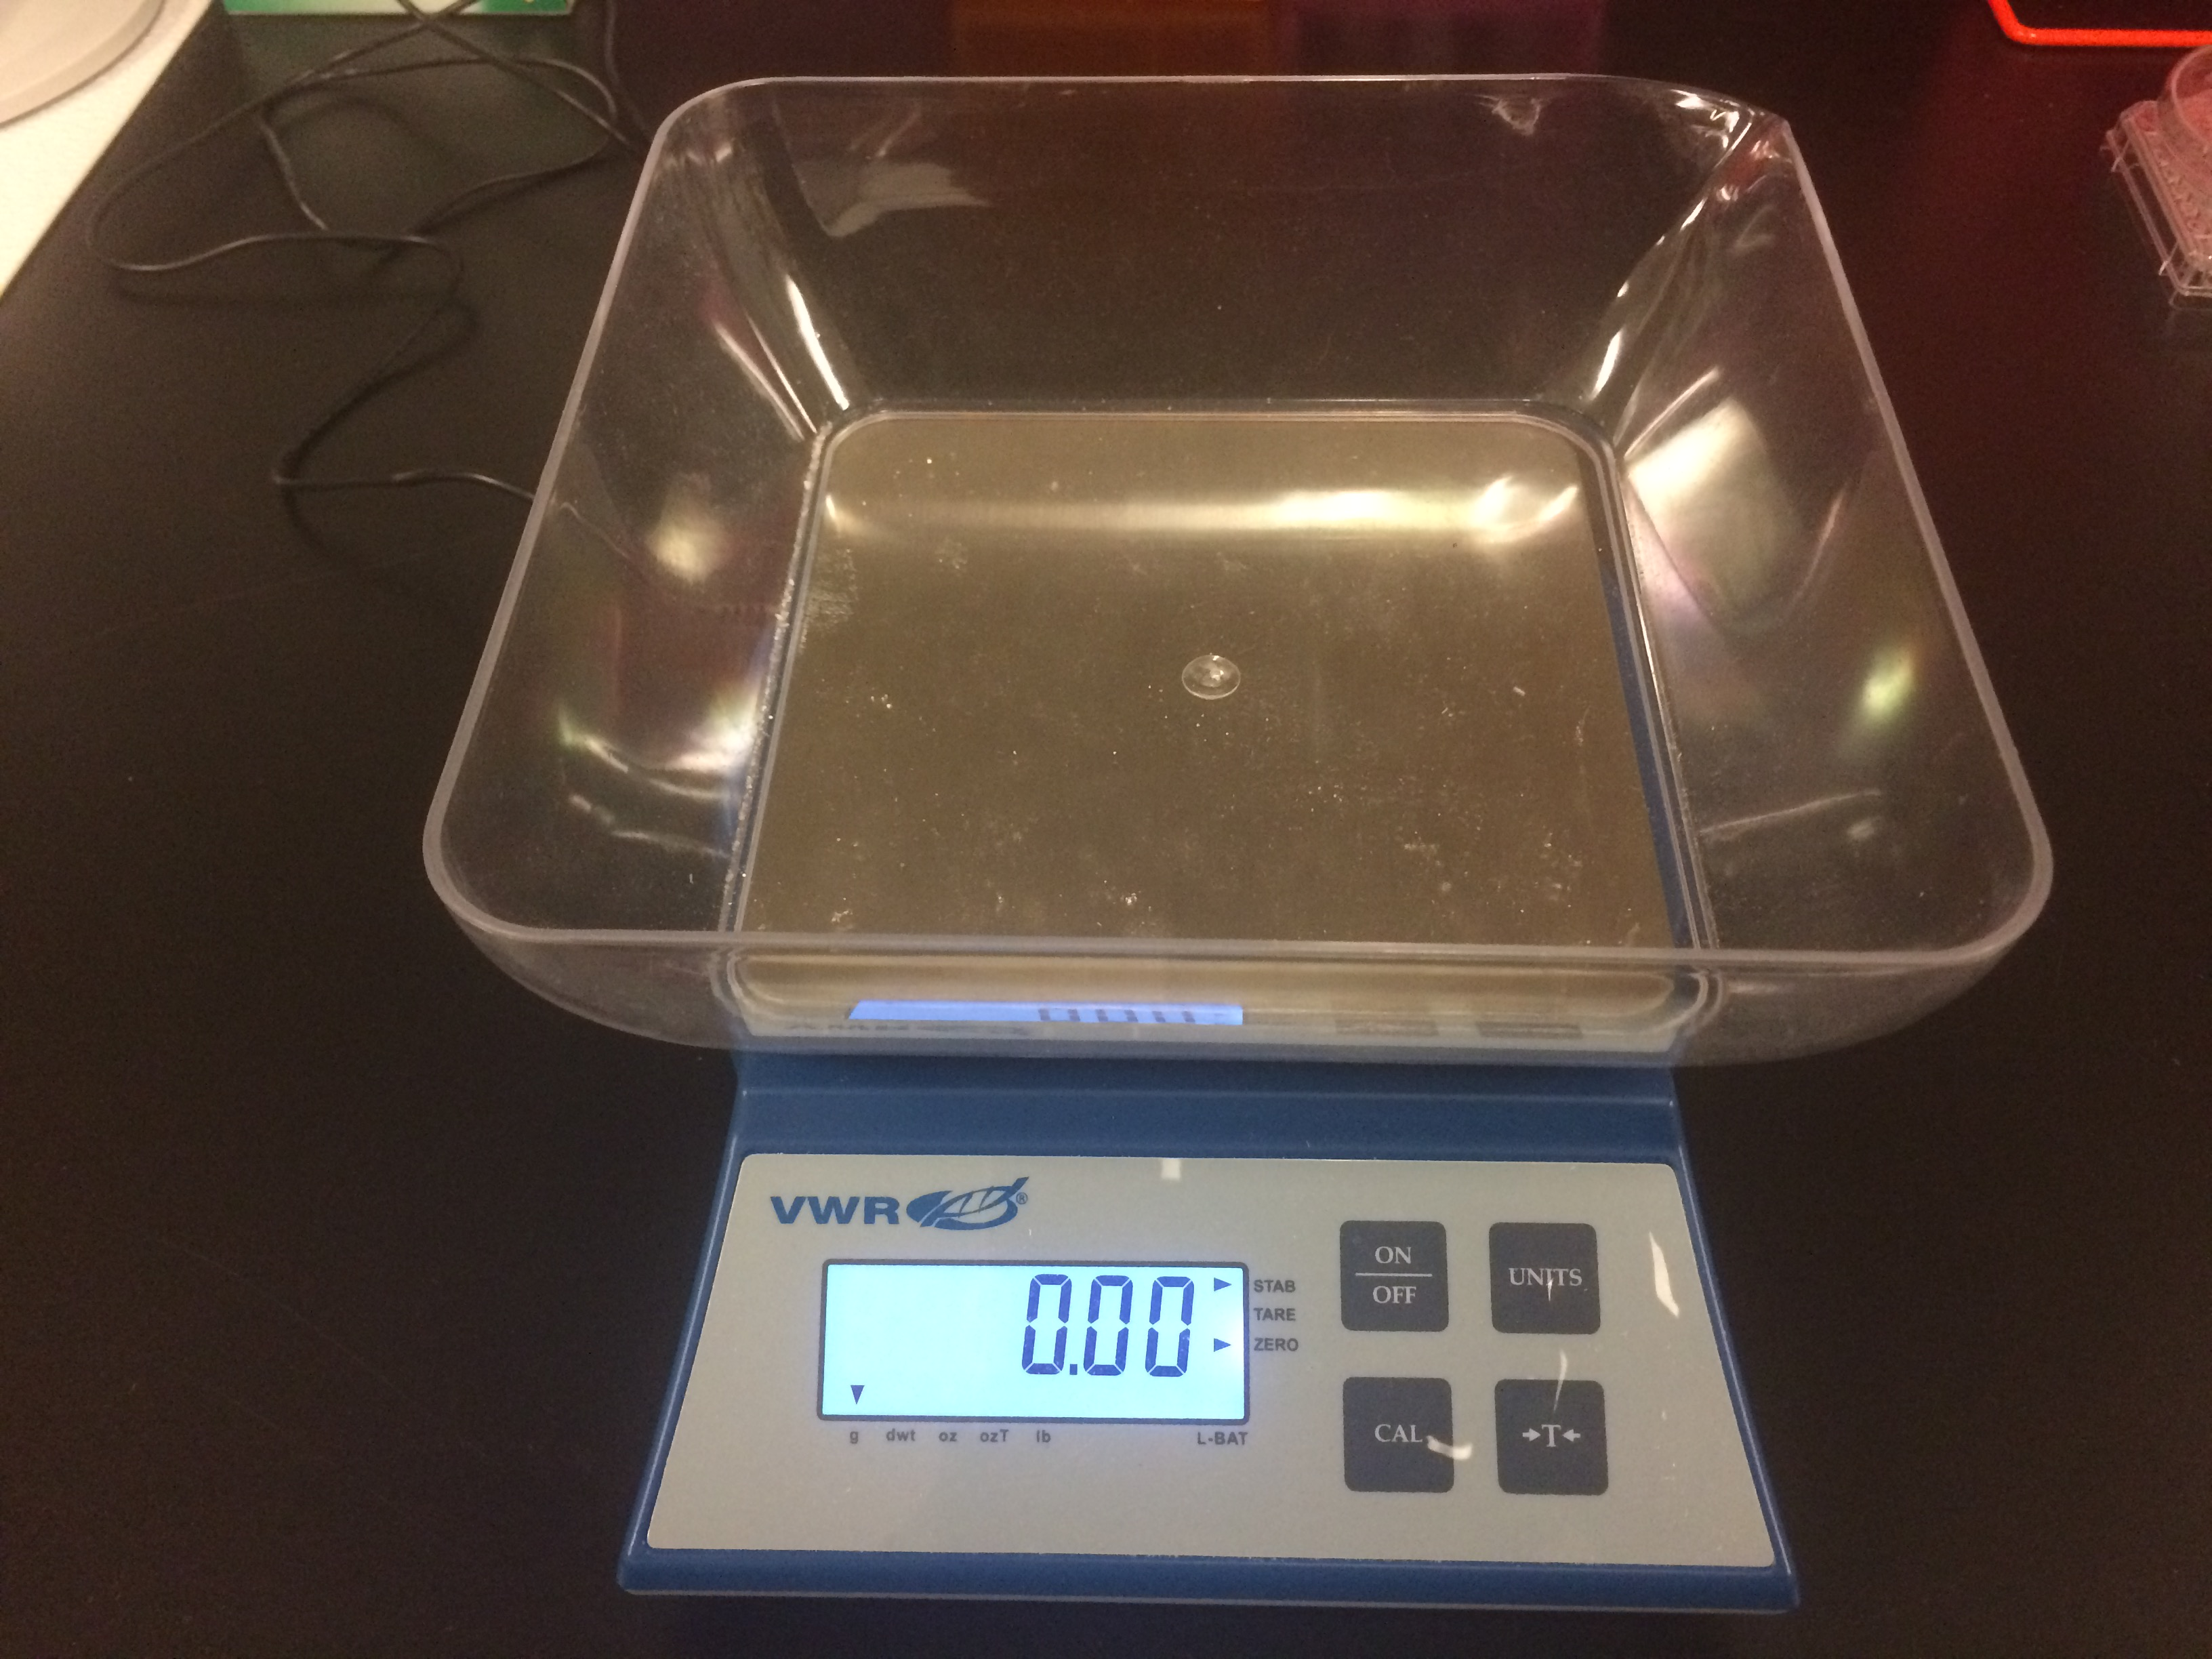

Figure 2: Turning on the scale

1. Place weigh boat in the center of the scale and press the “T” (tare) button, this resets the scale to zero.

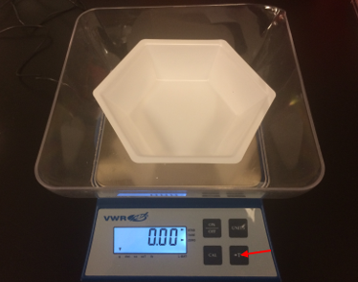

Figure 3: Taring the scale

1. The default units on this scale are in grams. If necessary, you may change the units displayed by selecting the “Unit” button. The display will cycle through the available readouts with each button press, shown in figure 4.
2. Add chemical sample to the weigh boat using a clean scoopula. Add small amounts to achieve the target weight. Wait a few seconds for the stabilization indicator in the top right corner of display to appear before adding more sample, shown in figure 5. Never put excess sample back into stock chemical containers.

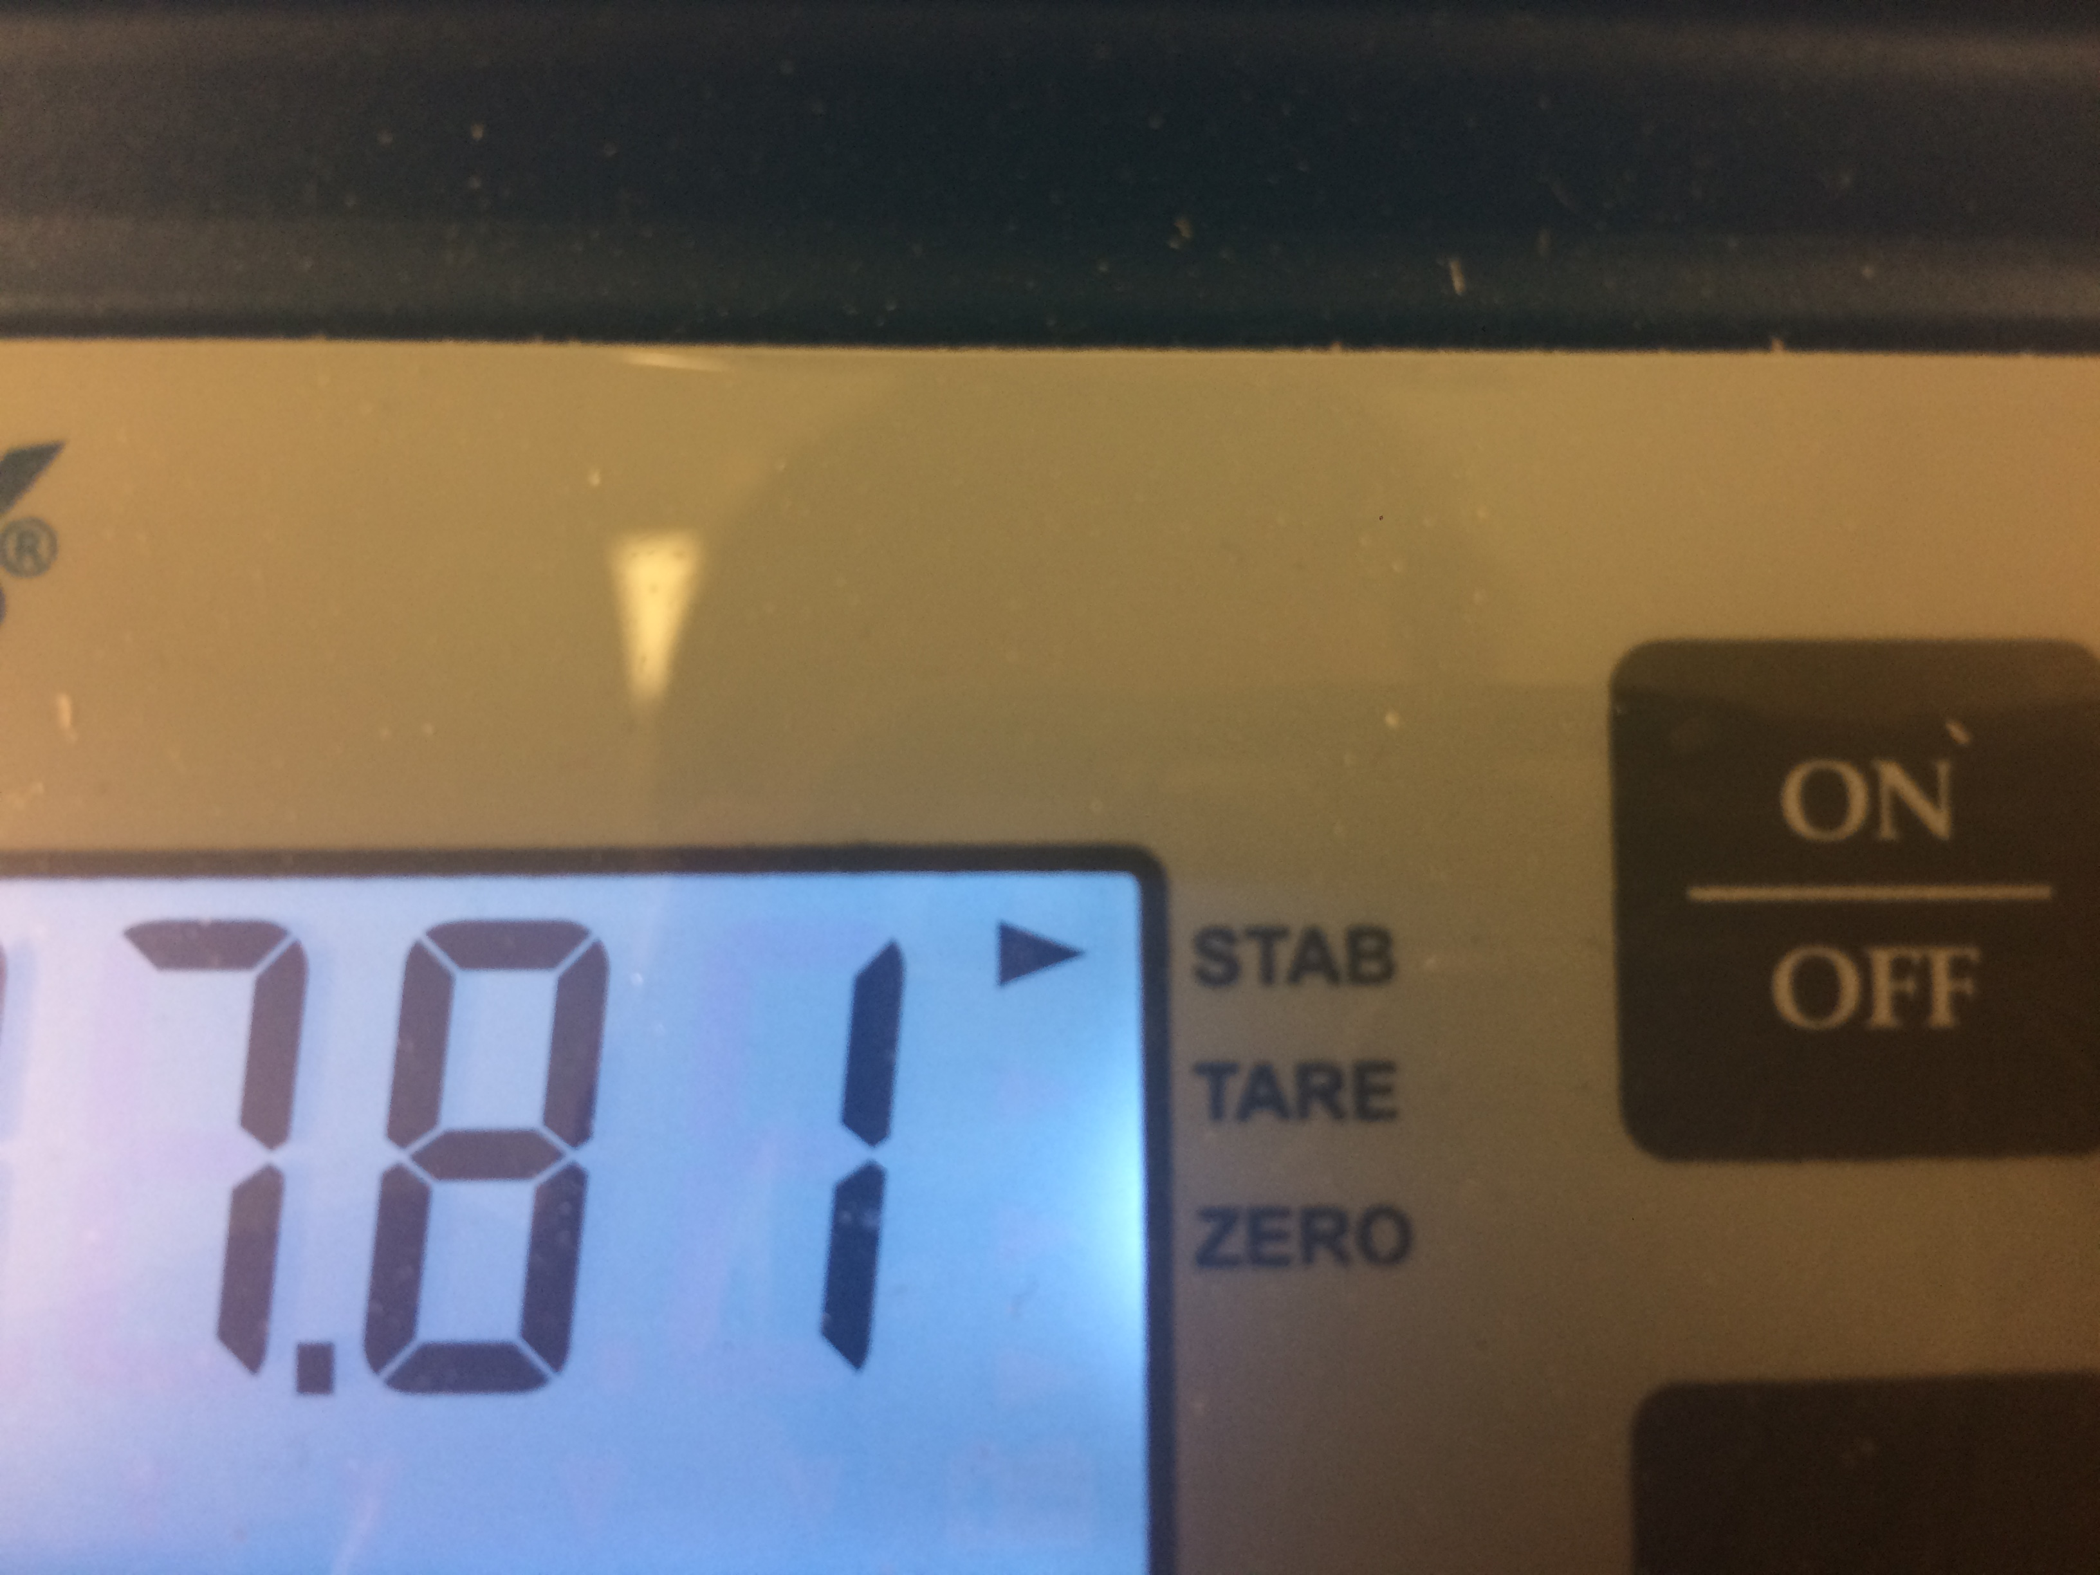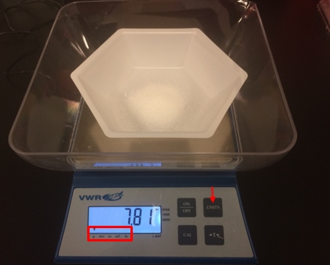

Figure 5: Stabilization indicator

Figure 4: Changing the units displayed

1. If weighing additional samples, remove the weigh boat and repeat steps 2-4 with a clean weigh boat for each sample. If finished weighing chemicals, remove the weigh boat and turn the instrument off by selecting the “On/Off” button.
2. If chemicals were spilled in the plastic tray during weighing, remove tray from the scale and wash with soap and water before returning.
3. Dispose of your gloves, waste material, and weigh boat in the hazardous waste bin when finished.