Sections of a Sample PB&J SOP
SOP | What could go wrong?
Objective
To guide a user through building a peanut butter and jelly sandwich. | Seems like we are off to a good start. The statement that this is used to build a single sandwich could help clarify if this is the correct SOP for the user’s needs. “To guide a user through building a single peanut butter and jelly sandwich.”
Materials
Peanut butter | Quantity: 5 gallons, 5 grams?  Quality: Smooth or Chunky?  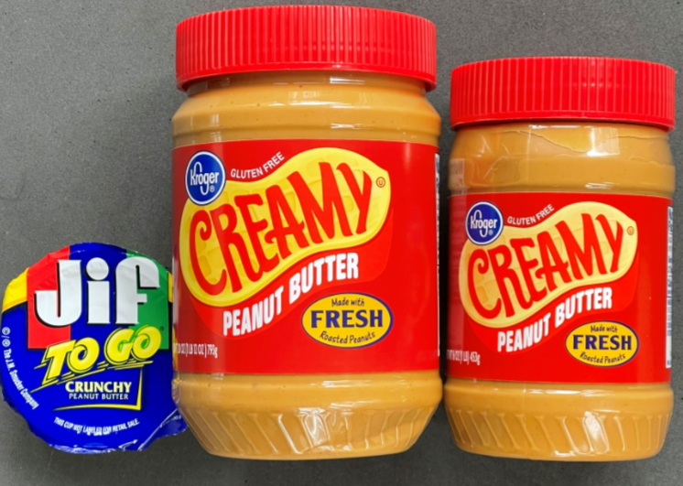  Manufacturer: Does it matter what brand?  Alternate Materials: SunButter ok? Could peanut butter slices may be used in place of a spread? Could combined peanut butter and jelly be used by drawing separate amounts of peanut butter and jelly?  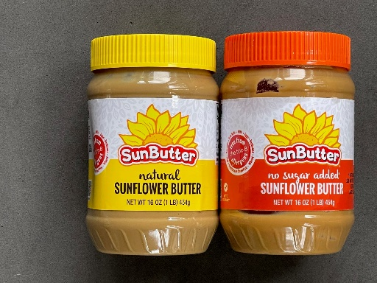  Cold peanut butter may tear bread. Specify that the peanut butter should be at room temperature.
Slices of Bread (Quantity 2) | Type (wheat, raisin, …), Size, Acceptable size range (variability between components). Does anyone like the heal?  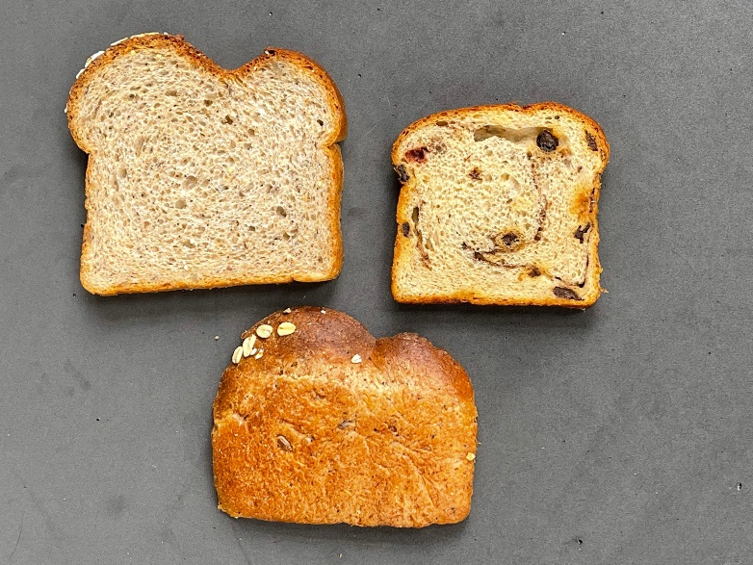  Alternatives?  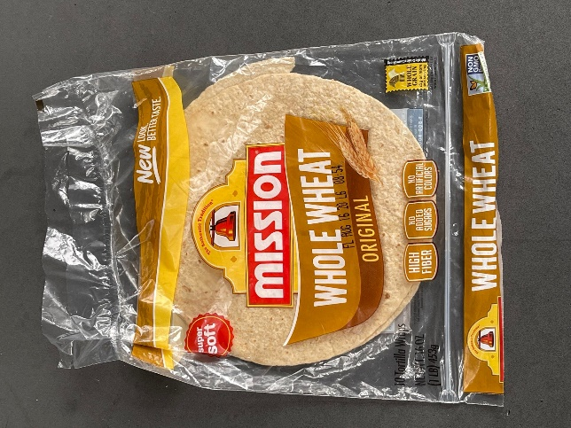
Jelly | Flavor of jelly may be important OR maybe you are writing a procedure that can use any flavor jelly.  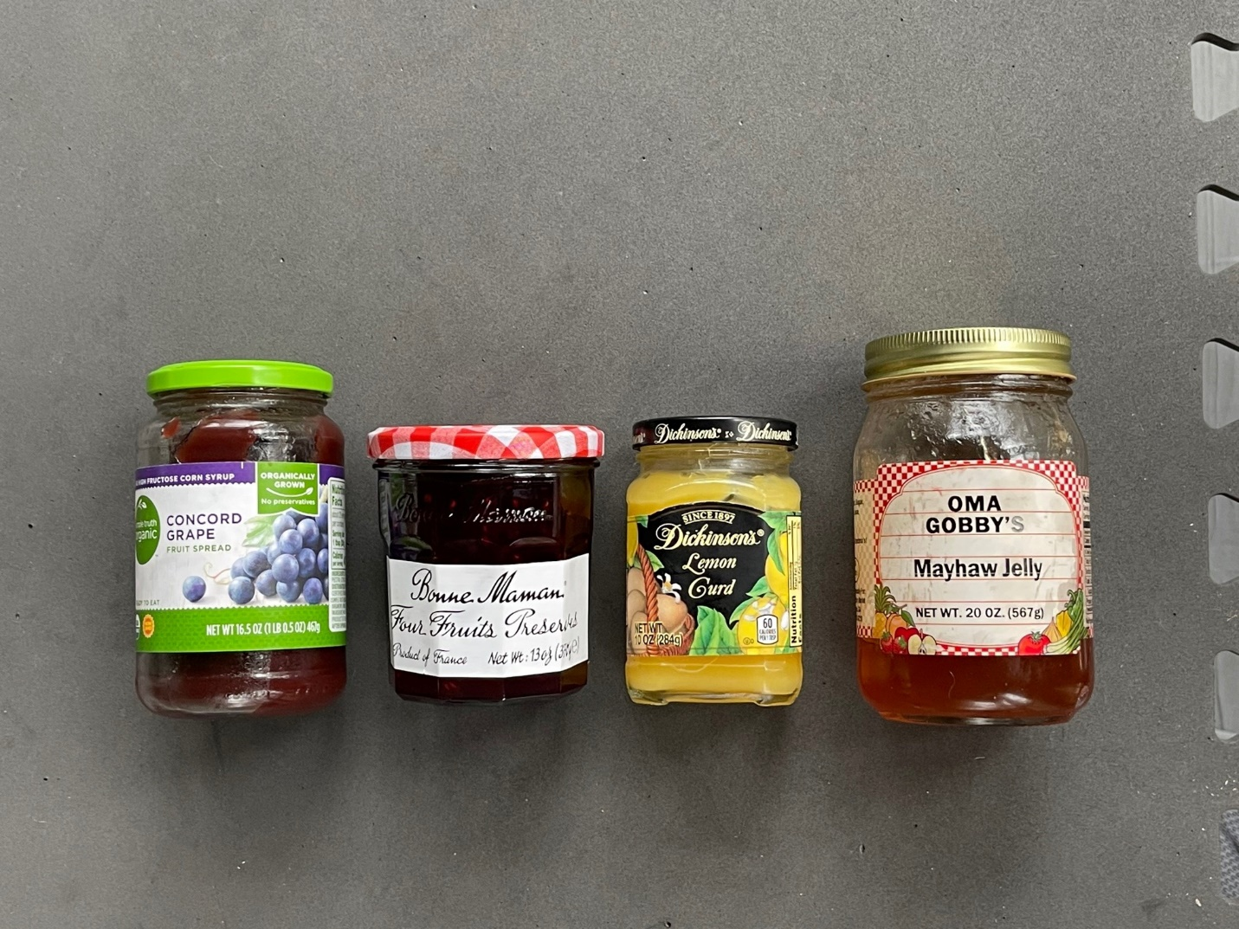
Equipment
Knife | There are a lot of different implements someone may choose. Is the type of tool important to your process? If yes, specify what should be used! Model Number: Metal or plastic  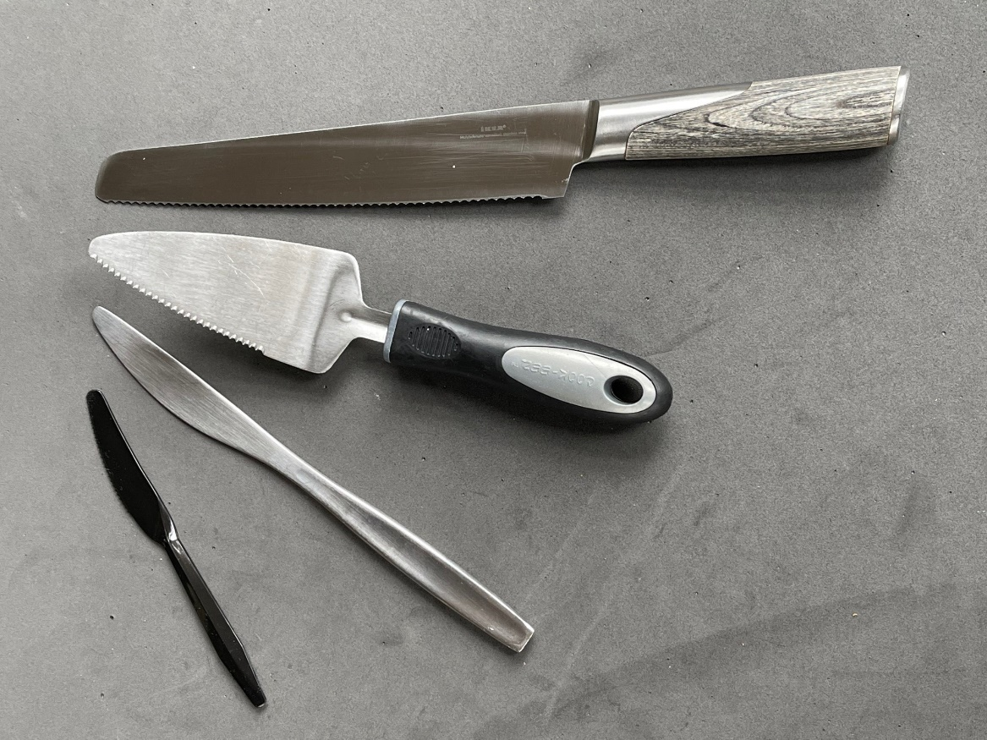

Procedure
Assemble Supplies | Does it matter where you assemble the sandwich? Is sterile technique or clean hands required?  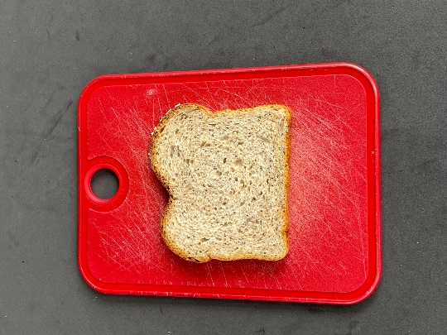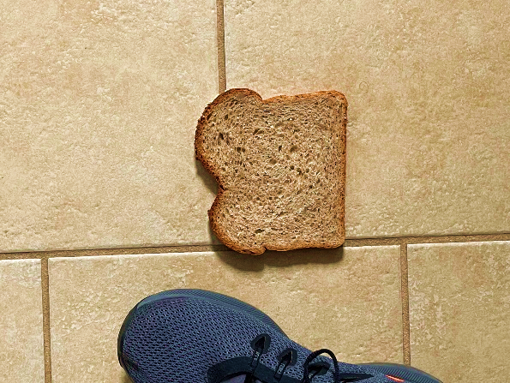
Use knife to spread peanut butter on a side of a slice of bread. Use knife to spread jelly on one side of the second slice of bread. | We are finally there, spread the peanut butter and jelly. Everyone knew what you meant?  Pattern:  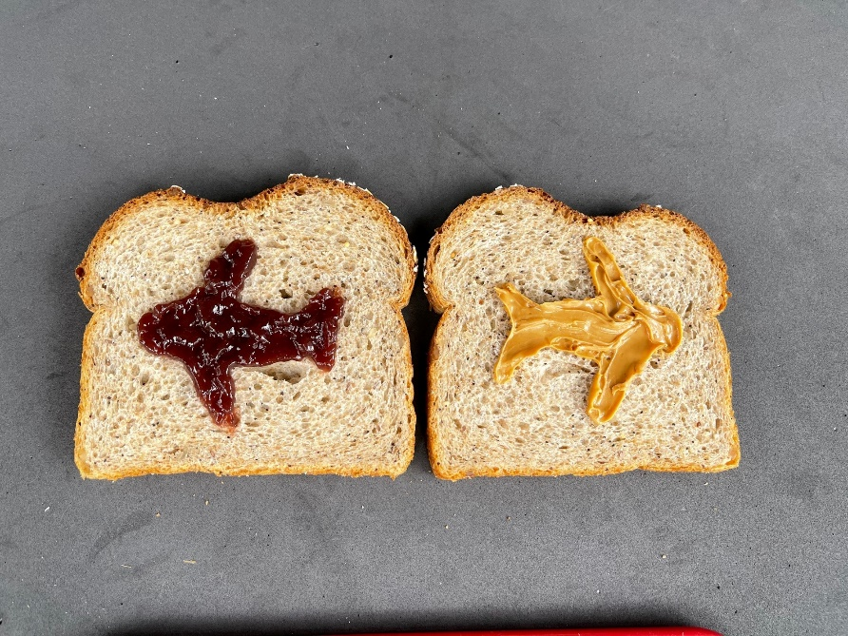  Same amount of peanut butter and jelly?  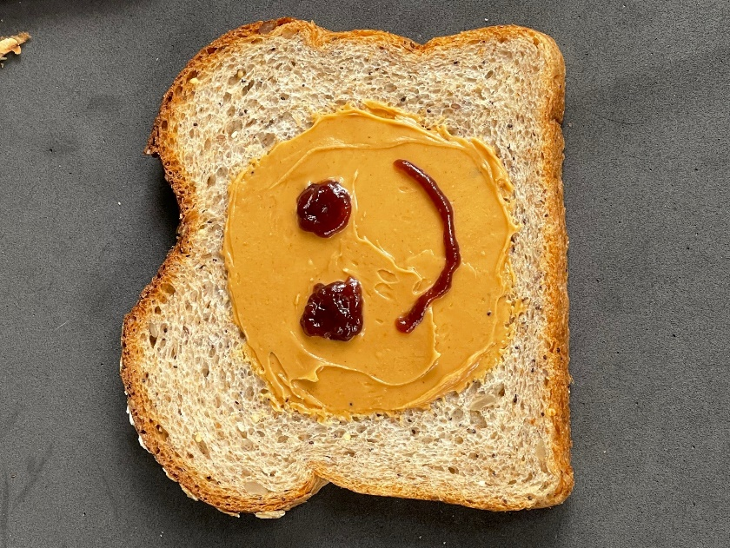  Optional step: Bread could be toasted before spreading without affecting the following steps of the SOP. Be sure to follow the SOP for using the toaster.  Clean knife between spreading peanut butter and jelly. Cross-contamination of jelly may be ok (since it is refrigerated) but may not want jelly in peanut butter.  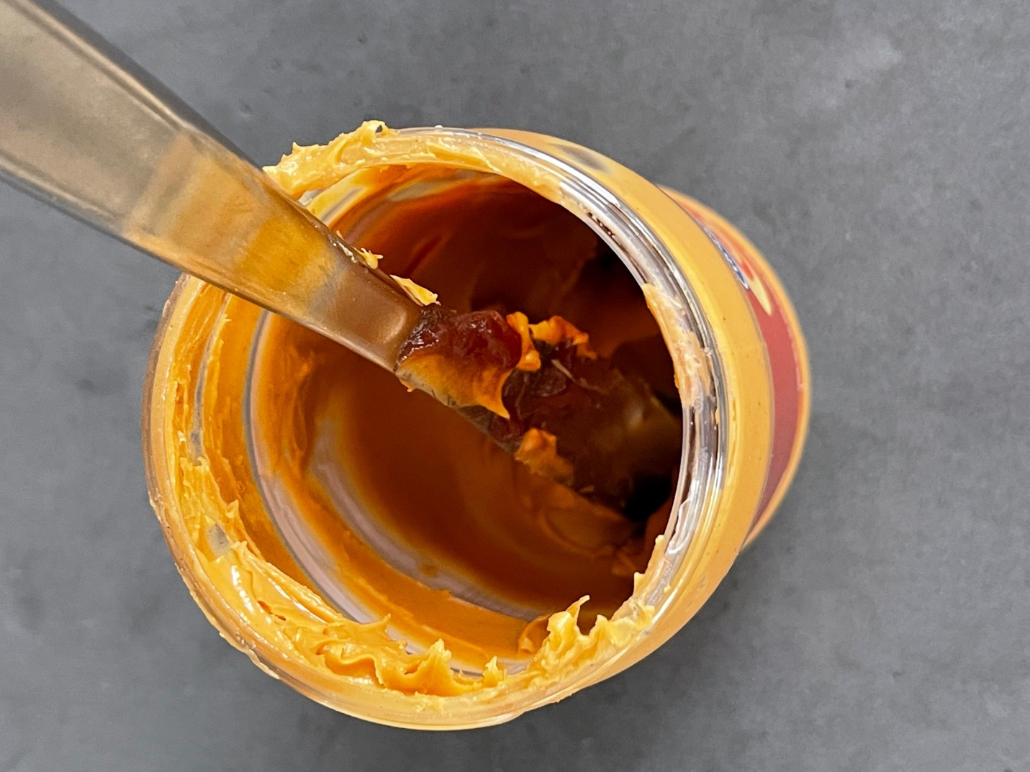

Put slices together | Relative orientation:  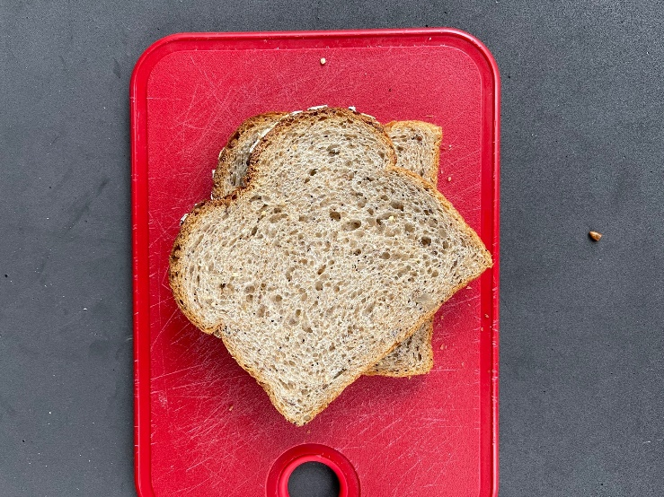  Maybe all sandwiches should be rolled like a gyro.  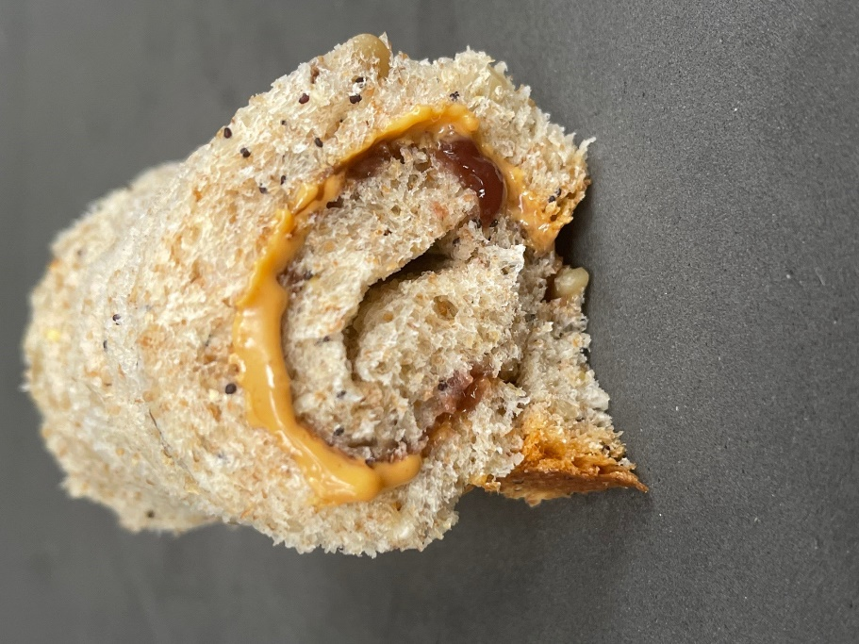  We may not all stack the way you envisioned. Does this matter?
Cut | Importance of a common language. Individuals may have different customs or usual ways of doing things.  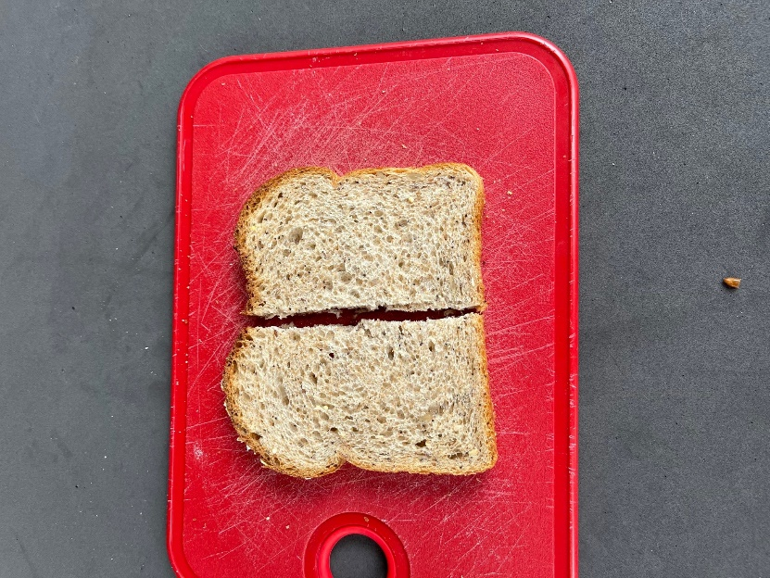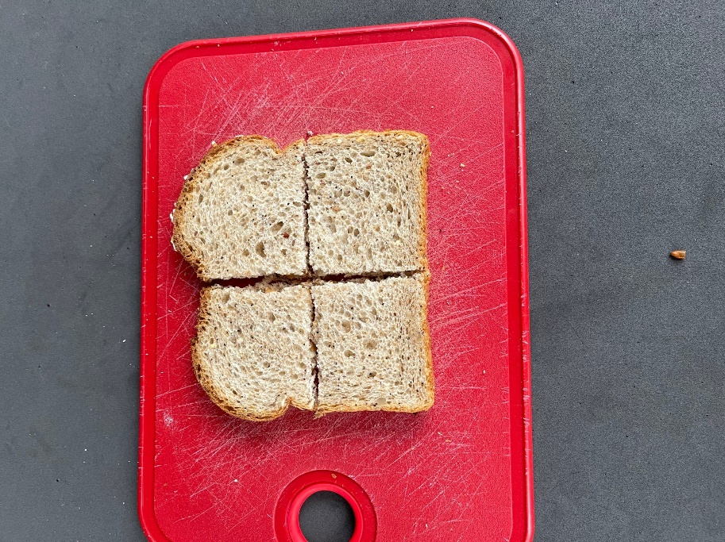  Should trimming crust be a standard or optional step? Should it be done before or after spreading peanut butter.
Return supplies | Do you clean knife?  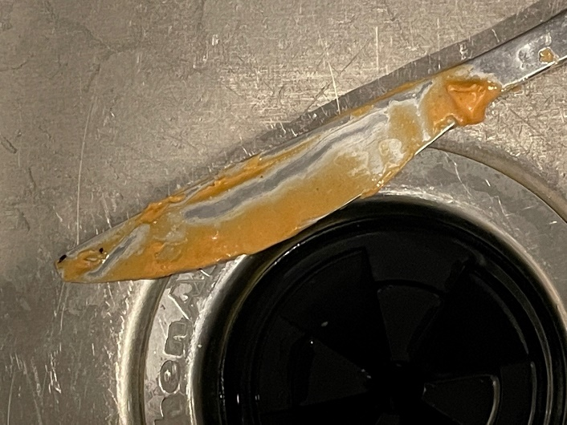  What about clean up? Are there special disposal procedures for an empty peanut butter jar?  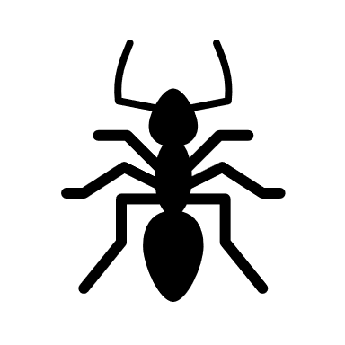
Figure shows the finished product  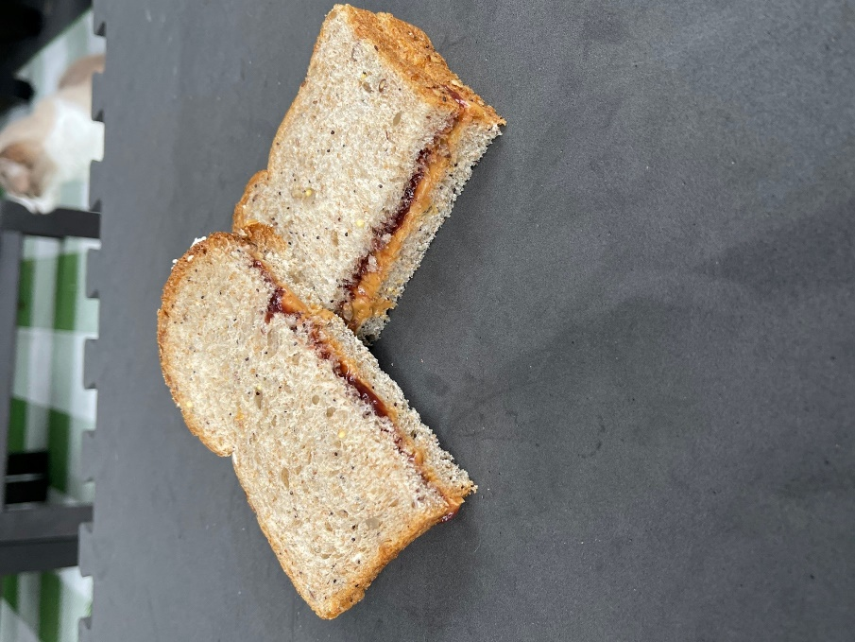 | We like this! Figures are valuable as you try to reproduce someone elses work.  Did your user make the sandwich that you wanted?  Was it trickier than you thought to write a good SOP?

