Module: REFERENCE MANAGEMENT

OVERVIEW

Learning Objectives

At the conclusion of this module, you will be able to:
- [Interpretation] Describe the purpose and importance of reference managers
- [Interpretation] Summarize some basic features of reference managers
- [Evaluation] List several good and bad practices when using reference managers
- [Application] Import publications into reference managers and manipulate data entries
- [Application] Create citations and bibliographies from a reference manager

Materials for this Module
- Handout 1: Citing Patents
- Reference Manager software (installed on your computer and your account created)

Introduction
Citations and References:
A citation is an acknowledgement in a paper or article that indicates a statement, idea, graphic, etc. was derived from an external source. The purpose of including a reference is to:
- Show the source of the data
- Support a statement in your work
- Provide a source of additional details
- Credit another researcher or research group for an idea or achievement
As seen in Figure 1, a citation typically includes a marker in the text, such as a number or the name of authors, which matches a detailed description of the source in the bibliography section of the paper.
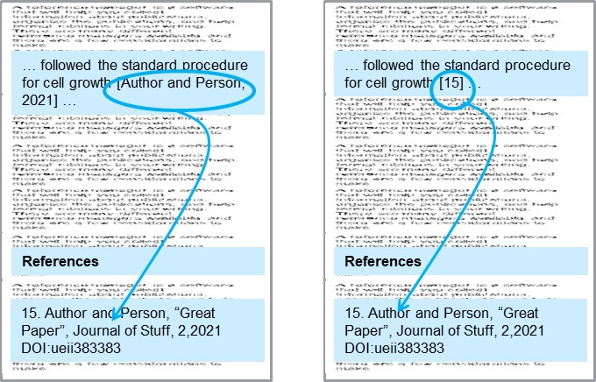
Figure 1: A citation matches information in the text, using an in-text citation, to a source.

Different disciplines place more emphasis on certain reference data, such as date, journal, or author. The format of the in-text citation will reflect this. For example, the IEEE citation style in-text marker is simply a number inside a square bracket (right image in Figure 1). In contrast, science papers often use the APA style, where the in-text citation includes the date of the work after the authors name because more importance is placed on the timeline of the work (left image in Figure 1).
There are also differences in bibliography entries. For example, MLA styles used in humanities list the date much later in the bibliography citation than other formats because this is considered less important. Journals within the same discipline often require different reference styles. Common standards include:

- MLA style (humanities)
- APA style (social sciences)
- Chicago author-date style (sciences)
- Professional/technical societies provide styles, including ASME (mechanical), IEEE (electrical), and ACM (computing)
Reference Managers:
Figure 2 illustrates that the reference manager is a software that will help you collect information about publications, organize the information, and help format citations in your writing. A reference manager should perform three essential functions:
- Easily collect article information
- Organize information
- Create citations in your writing.
First, the reference manager should support features that allow you to import the publications directly from your browser or desktop. This capability allows you to instantaneously save all your articles in one defined space. This is all done automatically though a browser extension of the reference manager (if supported). However, it is important to know that while the article will be imported automatically, sometimes important information regarding the publication is omitted (or nonsensical information is included!). Therefore, it’s important that you verify the listing is complete within the reference manager and manually fill in all information fields that may be missing.
Second, once your articles are stored in the reference manager, you can sort them in many ways such as by author, title, publisher, etc. You should also be able to add your own keywords or organize the articles by categories as you synthesize your understanding and organization of the literature. This will allow you to search your reference manager for all the articles you found on a topic, such as "tissue engineering".
Third, there are many citation styles available within your reference manager and the one you choose is dependent on the type of document you are writing. Remember that the purpose of a citation in your paper is so that the reader can retrieve the same information you used in supporting your writing. The information needed to retrieve a specific article may include:
- Names of authors
- Dates
- Source such as publisher of a book, name of a journal, name of conference proceedings, …
- Issue number, volume number, pages numbers
- The Digital Object Identifier (DOI), doi.org, is evolving as a system to provide any piece of work (article, books, …) with a unique number that can be used to locate that work.
A reference manager should allow users to automatically update each citation within the bibliography of the document. For example, if you imported three different citations within your document and decide later to change the order of citation; the reference manager is able to automatically update the entries in bibliography according to the listing order within the document. This feature is especially important for longer documents where you may have hundreds of citations and updating your bibliography every time a change is made is not feasible. Many reference managers have add-ons for Microsoft Word so that the software interfaces seamlessly, streamlining the process of creating citations.
There are many different reference managers available and there are a few general considerations to make when choosing one.
- Some software is free, others require a subscription fee or an upfront cost.
- Some provide multi-platform desktop versions while others are completely web-based.
- One of the most important factors in determining what reference manager to use will be the one that your colleagues use and your workplace supports. If you work at a university, the library will often have a subscription service to a reference manager offered for free to faculty, staff, and students. If you work for a private company, there may be a particular software that is preferred for the company workflow. A few recommended choices for researchers are: Zotero and Mendeley (available for free), RefWorks, or Endnote.
A comprehensive comparison between reference managers can be found at:
https://en.wikipedia.org/wiki/Comparison_of_reference_management_software

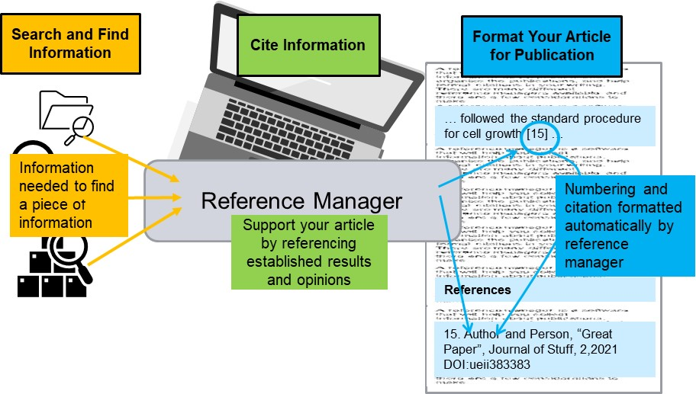
Figure 2: A reference manager will help you collect, organize, and share information about publications.
Know Your Librarian:
Your librarian knows about reference managers and can help you choose (but only if you ask). Your librarian can also help you conduct a literature search and save the results! Some libraries, such as the ones on university campuses, have an easy “chat” feature that allows you to get help from a librarian virtually, making it even easier to get help when needed.

Assignment(s) for this Module
Citing a Patent:
Any source of information that you use in developing your work, even an email conversation, should be cited. For example, you will likely have the need to cite patents. Read over Handout 1 “Citing Patents” for some specifics on how to export patent information from different databases into your reference manager. You will need this information to complete Activity 1.

Reference Manager Activity 1:
If you are having trouble choosing a reference manager, consult the Wikipedia link in the introduction of this module or simply choose one of the free recommended managers (Zotero or Mendeley). Once you have installed the reference manager, install any available browser extensions. Additionally, (if using with Microsoft Word) make sure your reference manager is linked within Word (usually within the Tools). Import at least five journal articles into the reference manager. Try adding articles directly from your browser as well as from your desktop. View and update all entries pertaining to the publication. For example, typically only one author (if any) is automatically imported within the reference manager; update the entry so all authors are listed. Sometimes the entries may have missing or extraneous information; take the time to ensure each entry is complete and correct.
- Now try adding a patent. When completing these activities think long term. What information or keywords should be added to ensure you can easily search for this article a year or even five years from now? A small amount of work as you collect citations will save an enormous amount of work later!
- Within an MS Word document, write a short, one-paragraph summary of an article that’s found within your database. Add a citation of the article you summarized to the document from the reference manager. Then, create a bibliography using the new citation you just added.

Deliverable 1: Document your responses to the Reference Manager Activity 1.

Reference Manager Activity 2:
- Add a second paragraph to the MS Word document (can be a summary of another article). Add another citation from your reference manager. Within the MS Word document, change the order of where the citations appear. If done correctly, your bibliography should be automatically updated.
- Change the citation style of your references, consulting your reference manager user guide. Some reference managers will require changing styles directly from the reference manager while some will have an option to change the style using an MS Word plugin installed with the reference manager.

Deliverable 2: Document your responses to the Reference Manager Activity 2.

Five-Minute Reflection:
- Should you use reference managers even when completing a small project that only requires a few citations? Why or why not?
- List any problems you may have encountered while completing the activities.
- Formulate one question to discuss with your mentor (maybe a concept you are unclear on, something you found interesting, etc.)
- What information did you feel was the most informative? Least?

Deliverable 3: Document your responses to the Five-Minute Reflection.

Mentee Deliverables:
- Deliverable 1: Responses to the Reference Manager Activity 1 (Overview).
- Deliverable 2: Responses to the Reference Manager Activity 2 (Overview).
- Deliverable 3: Responses to the Five-Minute Reflection (Overview).

Discussion with Mentor:
- Importance of citation management
- Citation management platform options and expectations
- Five-Minute Reflection
Summary
- Reference managers can make your research and writing more efficient by collecting, storing, and organizing article information.
- Reference managers make writing easy by automating the citations to insert into your papers.
- Citation style preferences vary from source to source.

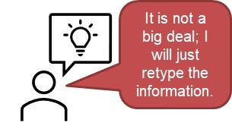 | 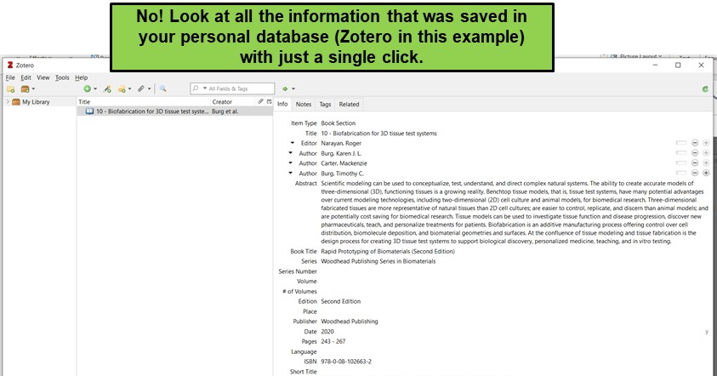
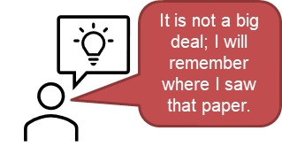
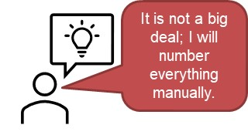 | 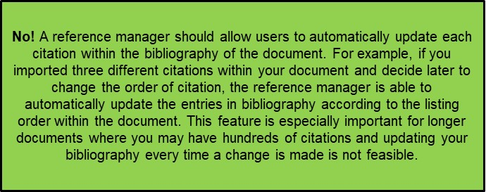

Checklist

Prior to Meeting with Mentor:
- Review Handout 1: Citing Patents
- Complete Reference Manager Activity 1
- Complete Reference Manager Activity 2
- Complete the Five-Minute Reflection

