Laboratory Notebook

Why do I need a lab notebook?
To document data and process parameters so that the experiment may be repeated. (Tomorrow you really will not remember what seemed obvious today!!). To claim patent rights. To capture observations and thoughts before you forget.

Does the notebook belong to me?
While you are working for a company, university, or medical center, the notebook remains in your possession. However, the notebook and the data is the property of your employer and remains with your employer after your departure.

What do I enter in my notebook?
All entries should be in permanent ink, no pencil. Include enough detail for a colleague with similar knowledge and understanding of the field to recreate the experiment. Some examples are:
- Schematics of experimental setups
- Table of experimental parameters
- Observations (qualitative) and results (quantitative)
- List of equipment and supplies WITH identifying information (e.g. model, size, company)

Should I make all my notebook entries at the end of the week when I have more time to think?
No! (Tomorrow you really will not remember what seemed obvious today!!)

When should I make entries in my notebook?
- Prior to lab work, write purpose/hypothesis
- During lab work, document procedure, equipment and data
- After lab work (set aside time at the end of the day to fill in gaps, write preliminary observations)

How do I make entries in my notebook?
- Sign it each day (name and date)
- Strike through blank lines, initial and date
- Tape paper data into notebook, sign so signature is on paper insert and notebook
- Never erase data, never scribble through data, never white-out entries
- Draw single line through mistakes, initial and date
- Use notebook with “permanent” bound pages, sequentially numbered
- Notebooks with carbon copies are highly recommended (give carbon copies to your advisor, supervisor)
- Electronic data should be archived (on a USB drive, for example) and referenced in the notebook.
- Industrial notebooks – each page should be countersigned by a witness.

Am I spending too much time entering information in my notebook?
Probably not. The goal is to capture all of the details that would be necessary to reproduce your experiment, ALL of the Details. This takes time! It is better to get to the end of an experiment with documentation that you may not use. rather than say. If you have to answer questions about your experiment with "Hmm, I don't know how I did that" or "I can't remember the machine setting for that", it may be impossible to reproduce the experiment and may make your results unusable. Experiments take a lot of time and resources to conduct, careful documentation ensures that we haven’t wasted this time or these resources.

Is the laboratory notebook enough?
Probably not. Take plenty of photos and videos. Save the photos with your other data. Refer to them in your laboratory notebook. They will be useful if you find that you have missed details in your notebook, sometimes as a backup to your notebook. They may also be useful when you summarize your project in a report, abstract, or paper and need to show a procedure. It will be difficult to recreate these photos after you have finished the experiment. Make quality photos. This takes time!

Example:
- The following image was made by depositing particles onto a sticky surface, tape. What was not documented, and could make a huge difference, is the type of tape used. Different types of tape will have different characterisitics that could affect how and where the particles stick. It would be difficult to exactly reproduce this work without knowing the type of tape used. The type and brand of tape matter!
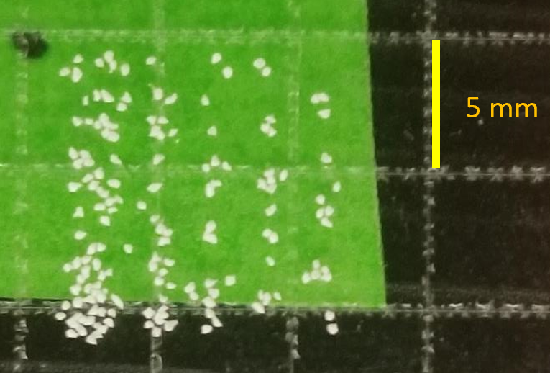
- A photograph from the experiment reveals that Staples brand packing tape was used and that it was ordered as "Staples® Moving & Storage Packing Tape, 1.88" x 109 Yds, Clear, 6/Rolls (ST-A26-L6)".

