MODULE: Finding Research Articles

OVERVIEW

Learning Objectives

At the conclusion of this module, you will be able to:
- [Interpretation] Describe different types of research articles, including Experimental Articles, Meta-Analysis Articles, and Review Articles
- [Evaluation] Choose an article to satisfy research needs identified by your mentor
- [Analysis] Compare different types of articles to determine which is appropriate for various needs
- [Analysis] Compare and contrast different types of sources and explain which sources are appropriate in different contexts
- [Evaluation] Evaluate various articles in terms of type, trustworthiness, freshness, and cost; explain the pros and cons associated with different sources
- [Application] Locate library resources at your institution
- [Application] Interview a librarian at your institution to determine valuable methods for your research needs

Materials for this Module
- Handout 1: Types and Sources of Research Articles
- On-Campus Library Resources

Introduction
As the figure illustrates, being able to find good research articles will be one of the most beneficial things to improving yourself as a researcher. The figure highlights how the work of many others supports your work. We will explore the variety of information sources available to you. There are three general factors you should consider about sources of information: trustworthiness, cost, and age of material. Some common sources of information you will use:
- Textbook - explains well established ideas and facts
- Thesis or Dissertation – graduate student's report of cutting-edge results and ideas
- Conference Presentation/Abstract – early phase reporting of emerging thoughts and ideas
- Journal Article - peer reviewed to ensure correctness.
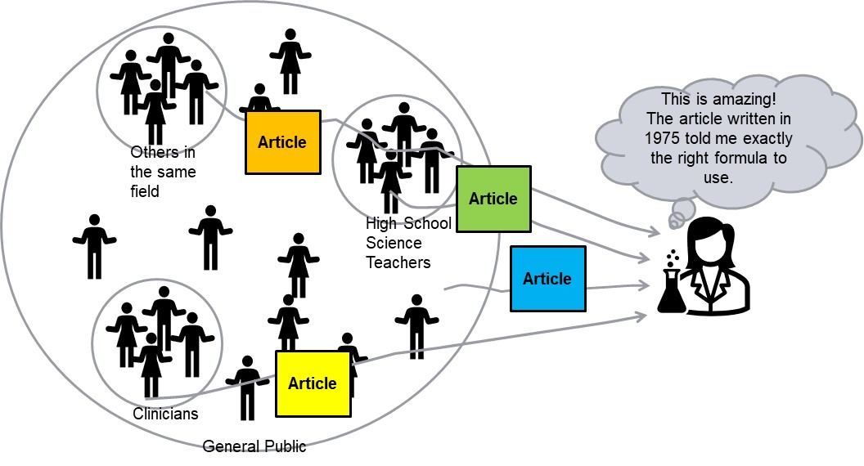
An overview of sources of information is provided here, but first review Handout 1 to see the details.
Types of Research Articles:
There are three main types of research articles:
- Experimental Articles - scientific communication about experiments and results
- Meta-Analysis Articles - secondary data analysis to find themes, trends in previously published work
- Review Articles - summary of research data from a particular topic
Trustworthiness - Who Creates and Organizes Information?
Many organizations create and publish information. The trustworthiness of an article or publication is related to trust in the organization and how they select, share, and publish information.
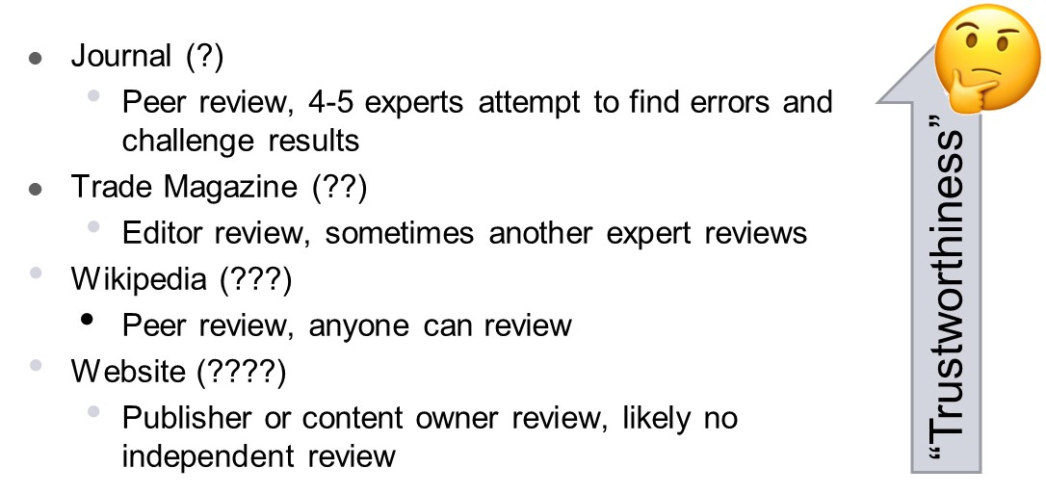
Sources such as Wikipedia and other websites are the least trustworthy because they are not reviewed by experts to ensure the information is accurate. Websites are only reviewed by the content owner or publisher, and Wikipedia can be reviewed by anyone!
Freshness – How Current is the Information?
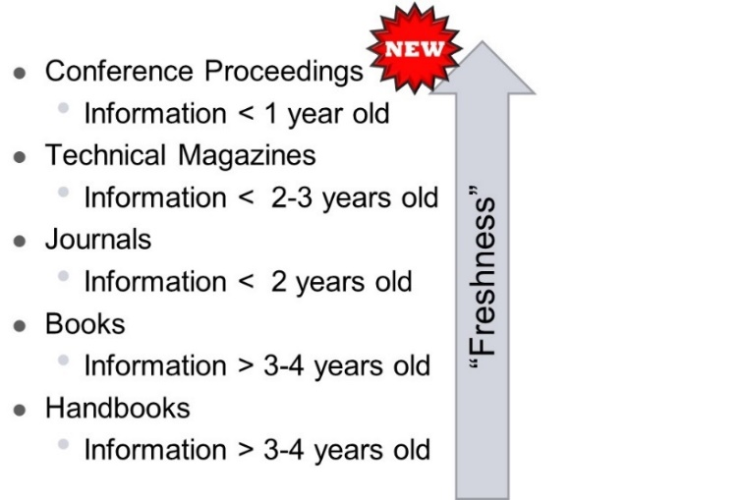
Cost – Who Pays?
There are two models for how articles can be published: the publisher model and open access model. With open access, the burden of payment is shifted from the reader to the author. Authors can expect to pay anywhere from $500-$10,000. This allows their material to be accessed for free by their readers. With the publisher model, readers have to pay a subscription for or a fee to access the material; an example of this could be a medical journal magazine, such as The American Journal of Medicine. Readers can access this material at no cost if they are a member of a society or institution that pays these fees.
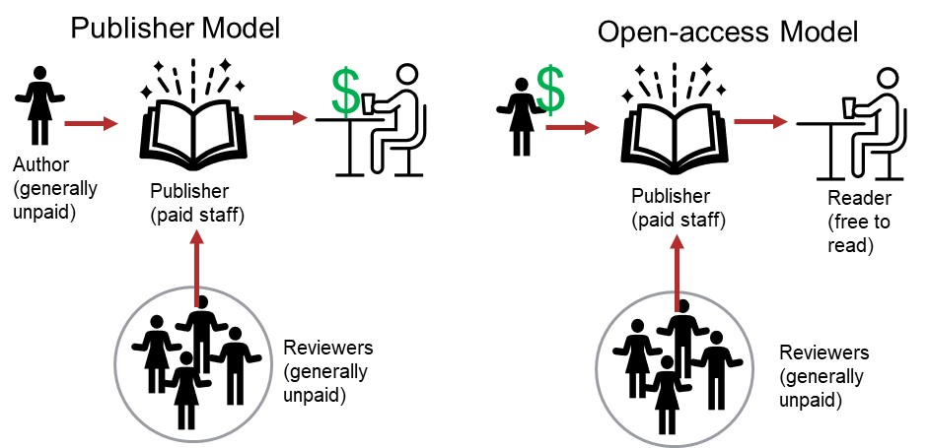
Know Your Librarian:
Learning to find good articles and knowing your institution's available resources will make your life much easier. The best way to do this is to talk to your librarian. Librarians are one of the best resources you have. They spend much of their time helping students search for articles and finding articles that are difficult to discover. Getting to know your librarian can help you improve your knowledge of how to search for articles and provide you an excellent resource when your literature searching isn’t going as you had planned.

Assignment(s) for this Module

Library Activity:
Your job is to locate your school librarians. This can usually be done easily by searching for your university and library. The university library webpage should list the available librarians. It is not uncommon for librarians to be subject matter expert for certain majors; so, see if you can locate a librarian who works directly with your department – they will be able to help you the most. Once you find out who they are, email them to see if they would be willing to meet to discuss research article locations and what resources the university offers.
- Who is the librarian and where are they actually located?
- Does your department have a specified librarian?
- Along with meeting in-person with a university librarian, become familiar with the university library website.
Once you have had a meeting with the librarian, answer the following questions (so be sure to talk about these topics in your meeting). Note: if you do not receive an email response from them, assume they did not receive the email. It is never a bad idea to just walk to their office to see if they are free or if you can set up a meeting with them at a better time.
- What are the best resources/search engines for locating research articles?
- What key words do you think would help you locate good research articles in your mentor’s field?
- What reference management platforms are supported by your university?
Deliverable 1: Document your responses to the Library Activity.

Five-Minute Reflection:
- Come up with one question to discuss with your mentor (maybe a concept you are unclear on, something you found interesting, etc.).
- What information did you feel was the most informative? Least?
- What reference management platform will you use to file research articles once you find them and why?
Deliverable 2: Document your responses to the Five-Minute Reflection.

Mentee Deliverables:
- Deliverable 1: Responses to the Library Activity (Overview).
- Deliverable 2: Responses to the Five-Minute Reflection (Overview).

Discussion with mentor:
- University research paper availability
- Cost of research articles – who pays? Considerations when applying to journal.
- Five-Minute Reflection
Summary
- Three factors you should consider about the source of information:
  - Trustworthiness - Information on the internet can be pulled from any source and can be written by anyone. It’s important to know where your information is coming from, and how trustworthy it is.
  - Cost - Some information is valuable and worth buying.
  - Age of material – different formats of information have more or less timely information.
- There are three different types of research articles (experimental, meta-analysis, and review); each serves a different purpose.
- Learning to find good articles and knowing your institution's available resources will make your life much easier.

Checklist:

Prior to meeting with mentor:
- Review Handout 1: Types and Sources of Articles
- Practice methods to locate research articles
- Complete Library Activity
- Locate a paper of relevant topic to mentor’s research
- Complete the Five-Minute Reflection

