Periodically, members of the Research, Experience, and Mentoring (REM) team have the opportunity to interview experts from academia, industry, and business on their experiences with research. This document serves as a repository for this resource.

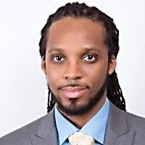 | Carl Lamar  Lead Customer Service Engineer  GE Additives  MS, Mechanical Engineering  Clemson University

Complete interview with Carl Lamar: https://youtu.be/vgVLoXgdiz0

Introduction
https://www.youtube.com/embed/vgVLoXgdiz0?start=0&end=75&rel=0

Describe your initial experiences with research as an undergraduate:
https://www.youtube.com/embed/vgVLoXgdiz0?start=77&end=146&rel=0

How were you introduced to the topic of your research?
https://www.youtube.com/embed/vgVLoXgdiz0?start=147&end=206&rel=0

What was your experience like when you first approached research literature?
https://www.youtube.com/embed/vgVLoXgdiz0?start=207&end=310&rel=0

Describe your relationship(s) with your advisors / research mentors:
https://www.youtube.com/embed/vgVLoXgdiz0?start=312&end=445&rel=0

What have you been able to take from your experiences with research into your current position in industry?
https://www.youtube.com/embed/vgVLoXgdiz0?start=446&end=589&rel=0

What was the decision process like when you made the choice to go from academia to industry?
https://www.youtube.com/embed/vgVLoXgdiz0?start=598&end=738&rel=0

What is the best piece of advice you received as an undergraduate in terms of approaching research?
https://www.youtube.com/embed/vgVLoXgdiz0?start=746&end=807&rel=0

What impact to the broader community have you been able to make through research?
https://www.youtube.com/embed/vgVLoXgdiz0?start=817&end=939&rel=0

What piece of advice would you provide to an undergraduate who is considering getting into research?
https://www.youtube.com/embed/vgVLoXgdiz0?start=942&end=1020&rel=0

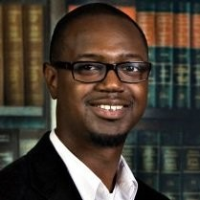 | Hamilton Allen  Director of Training and Technical Services  Senske Lawn and Tree Care  Ph.D, Entomology  Clemson University

Complete interview with Carl Lamar: https://youtu.be/WmXemmw7eac

Introduction
https://www.youtube.com/embed/WmXemmw7eac?start=0&end=34&rel=0

At what point of your educational career did you first start doing research?
https://www.youtube.com/embed/WmXemmw7eac?start=40&end=113&rel=0

What got you into the field you chose to study?
https://www.youtube.com/embed/WmXemmw7eac?start=114&end=185&rel=0

What were some of the ways that you found research opportunities?
https://www.youtube.com/embed/WmXemmw7eac?start=201&end=270&rel=0

What comes to mind when you hear the word ‘networking?’
https://www.youtube.com/embed/WmXemmw7eac?start=318&end=434&rel=0

What was the best piece of advice you received in terms of pursuing research?
https://www.youtube.com/embed/WmXemmw7eac?start=439&end=552&rel=0

What was the benefit of getting a breadth of research experiences?
https://www.youtube.com/embed/WmXemmw7eac?start=554&end=645&rel=0

What was it like when you were first introduced to reading research articles?
https://www.youtube.com/embed/WmXemmw7eac?start=654&end=825&rel=0

Who were the most influential people in your career, both undergraduate and graduate?
https://www.youtube.com/embed/WmXemmw7eac?start=840&end=990&rel=0

What were the benefits of having a research background to your current career?
https://www.youtube.com/embed/WmXemmw7eac?start=1007&end=1288&rel=0

What has been the toughest thing for you in transition into your current role (i.e., industry vs. academia)?
https://www.youtube.com/embed/WmXemmw7eac?start=1288&end=1403&rel=0

What broader impacts does your research have to the broader community?
https://www.youtube.com/embed/WmXemmw7eac?start=1414&end=1665&rel=0

What advice would you give to an undergraduate considering getting into research?
https://www.youtube.com/embed/WmXemmw7eac?start=1666&end=1761&rel=0

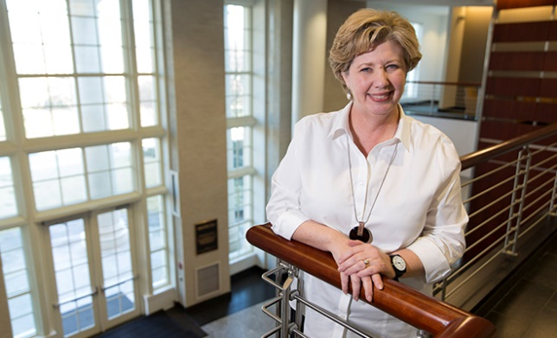 | Crystal Leach  Director of Industry Collaborations  University of Georgia  Ph.D, Textiles and Polymer Science  Clemson University

Complete interview with Crystal Leach: https://youtu.be/1iE_qZ4XNyg

Introduction
https://www.youtube.com/embed/1iE_qZ4XNyg?start=0&end=228&rel=0

What sparked your interest in research?
https://www.youtube.com/embed/1iE_qZ4XNyg?start=249&end=362&rel=0

How did you find out about research opportunities?
https://www.youtube.com/embed/1iE_qZ4XNyg?start=369&end=445&rel=0

What comes to mind when you think about the idea of networking?
https://www.youtube.com/embed/1iE_qZ4XNyg?start=452&end=551&rel=0

Regarding research, what was the best piece of advice you received as a student?
https://www.youtube.com/embed/1iE_qZ4XNyg?start=561&end=701&rel=0

What benefits to your development as a researcher did you gain from your independent, self-guided approach?
https://www.youtube.com/embed/1iE_qZ4XNyg?start=711&end=793&rel=0

Describe your experiences in first reading research articles or doing literature reviews.
https://www.youtube.com/embed/1iE_qZ4XNyg?start=817&end=921&rel=0

Who were the most influential people in your research career, both educationally and professionally?
https://www.youtube.com/embed/1iE_qZ4XNyg?start=924&end=1054&rel=0

What were the biggest differences in research culture between working in academia and business?
https://www.youtube.com/embed/1iE_qZ4XNyg?start=1080&end=1292&rel=0

What were some of the difficulties during the transitional phases of your career, and what would you consider to be your most spectacular failure?
https://www.youtube.com/embed/1iE_qZ4XNyg?start=1310&end=1500&rel=0

What advice would you give to an undergraduate considering getting into research?
https://www.youtube.com/embed/1iE_qZ4XNyg?start=1519&end=1629&rel=0

